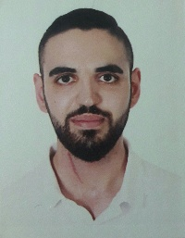
CV
First name: Elias
Last name: Attieh
Nationality: Lebanese
Date of birth: 13-11-1994
Place of birth: Rahbe, Akkar, Lebanon
Social status: single
Address: Zouk Mikhael, Mont-Liban, Lebanon
Phone number: +961 76 458 439
E-mail: elie.att94@gmail.com

Personal information:
Education:
- Diploma degree in “Economic and Sociology” at Elias Abou Chabkeh school (graduation year: 2013)
- Business management at “Arab Open University” (from 2014 – present)

Job experiences:
- Usher at ABC Dbayeh : 2014 ( 19 June - 7 December)
- Stock keeper at AZADEA Group : ( 8 December 2014 - 30 May 2016)
- Sales associate at Sport Et Loisir ( October 2016 – present )

Languages:
Arabic: well speaking, well writing, well reading
English: fair speaking, well writing, well reading
French: weak speaking, well writing, well reading

Computer skills:
- Microsoft word
- Microsoft PowerPoint

Activities:
- Camping
- Swimming

